Homework 3

## Question 3.1



a)

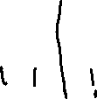

b)

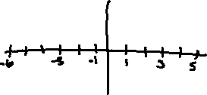

c)



d)

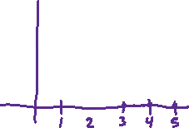

e)

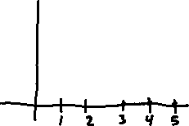

## Question 3.2

a)

|  |  |
| --- | --- |
| n | x[n] |
| 0 | 1.80 |
| 1 | -0.90 |
| 2 | -0.90 |
| 3 | 1.80 |
| 4 | -0.90 |
| 5 | -0.90 |

b)

|  |  |
| --- | --- |
| n | g[n] |
| 0 | 1.80 |
| 1 | 1.69 |
| 2 | 1.38 |
| 3 | 0.90 |
| 4 | 0.31 |
| 5 | -0.31 |

c)

|  |  |
| --- | --- |
| n | a[n] |
| 0 | 0.90 |
| 1 | 1.56 |
| 2 | 1.80 |
| 3 | 1.56 |
| 4 | 0.90 |
| 5 | 0.00 |

d)

|  |  |
| --- | --- |
| n | y[n] |
| 0 | 1.80 |
| 1 | 1.56 |
| 2 | 1.33 |
| 3 | 1.11 |
| 4 | 0.90 |
| 5 | 0.70 |

## Question 3.3

a) Linear, Time-Invariant

b) Linear, Time-Variant

c) Non-Linear, Time-Variant

d) Linear, Time-Invariant

e) Non-Linear, Time-Variant

## Question 3.4

a) Causal, IIR

b) Non-Causal, IIR

c) Non-Causal, FIR

d) Causal, FIR

e) Causal, IIR